HURDEBOURCQ Paul
TP4
R1-05 : BDD

Avoir_note (#numetu, #numepr, note)
Enseignants (numens, nomens, preens, foncens, adrens, vilens, cpens, telens, datnaiens, datembens)
Epreuves (#numepr, libepr, #ensepr, #matepr, datepr, coefepr, annepr)
Etudiants (#numetu, nometu, prenometu, adretu, viletu, cpetu, teletu, datentetu, annetu, remetu, sexetu, datnaietu)
Modules (#nummod, nommod, coefmod)
Matières (#nummat, nommat, #nummod, coefmat)
Faire_cours (#numens, #nummat, annee)

Travaux effectués : | A retenir :
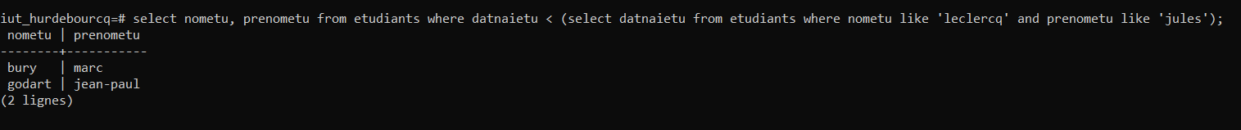 | Les noms des étudiants nés avant l'étudiant « JULES LECLERCQ »
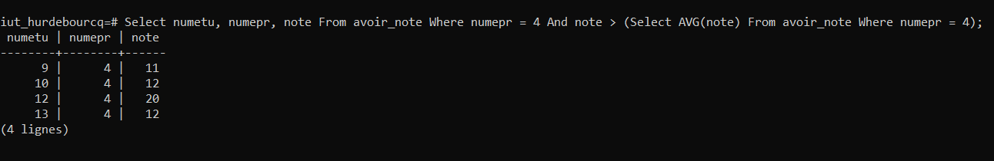 | Select numetu, numepr, note From avoir_note Where numepr = 4 And note > (Select AVG(note) From avoir_note Where numepr = 4);
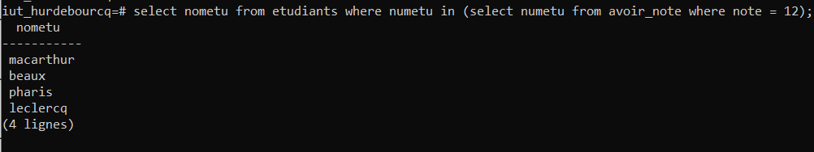 | select nometu from etudiants where numetu in (select numetu from avoir_note where note = 12);
 | Select Et.nometu from etudiants as Et inner join avoir_note as A on et.numetu = A.numetu inner join epreuves as Ep on A.numepr = Ep .numerp where A.numepr = 4 and A.note > (select A.note from avoir_note as A where A.numetu on (select Et.numetu from etudiants as Et where Et.nometu =’dupont’) ;
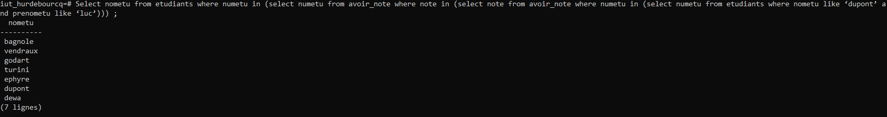 | Select nometu from etudiants where numetu in (select numetu from avoir_note where note in (select note from avoir_note where numetu in (select numetu from etudiants where nometu like ‘dupont’ and prenometu like ‘luc’))) ;
Page 1/ 28/10/21

